Tutorial link: <http://igorzelmanovich.blogspot.in/2012/03/setting-up-git-git-extensions-and.html>

http://www.tikalk.com/net/setting-git-git-extensions-and-github-account

GitHub Extension (.exe)Download link :<http://goo.gl/PHbqK> or <http://msysgit.github.io/>

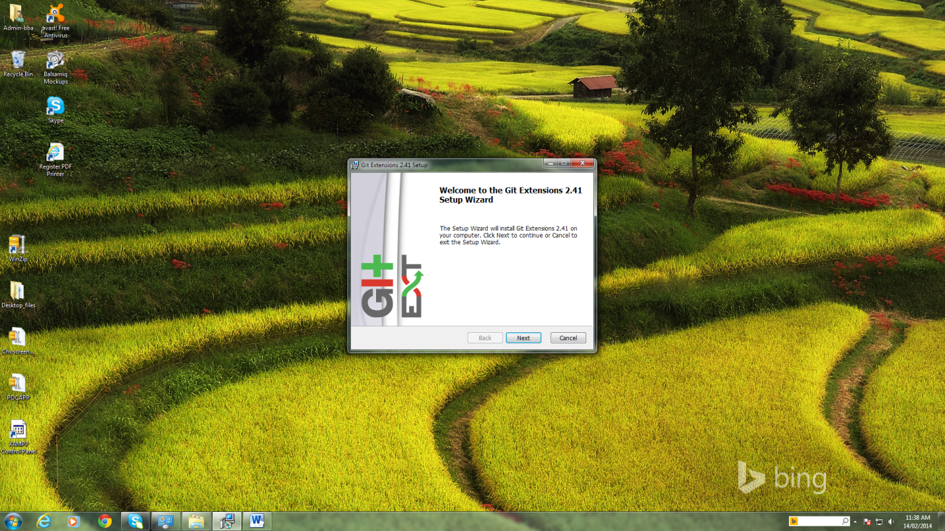

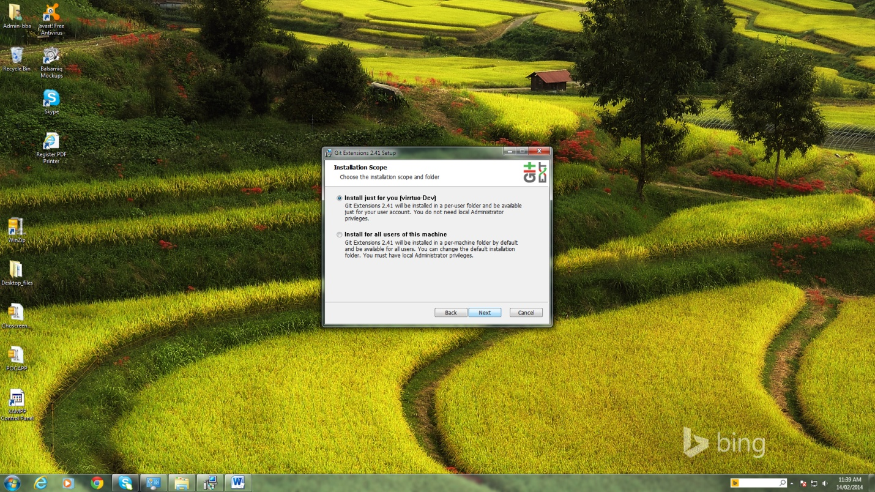

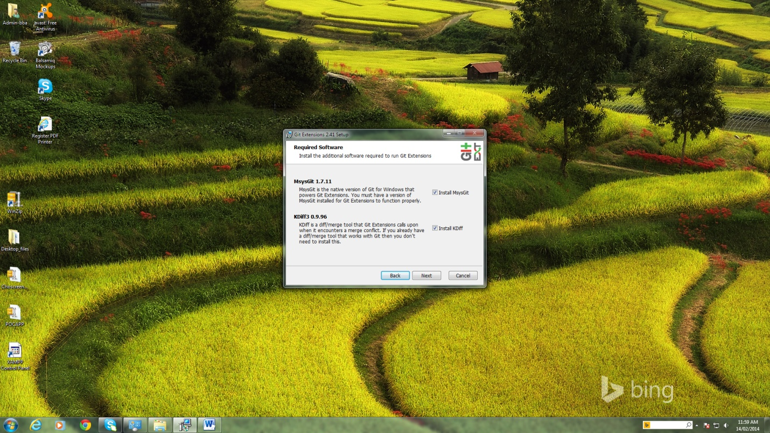

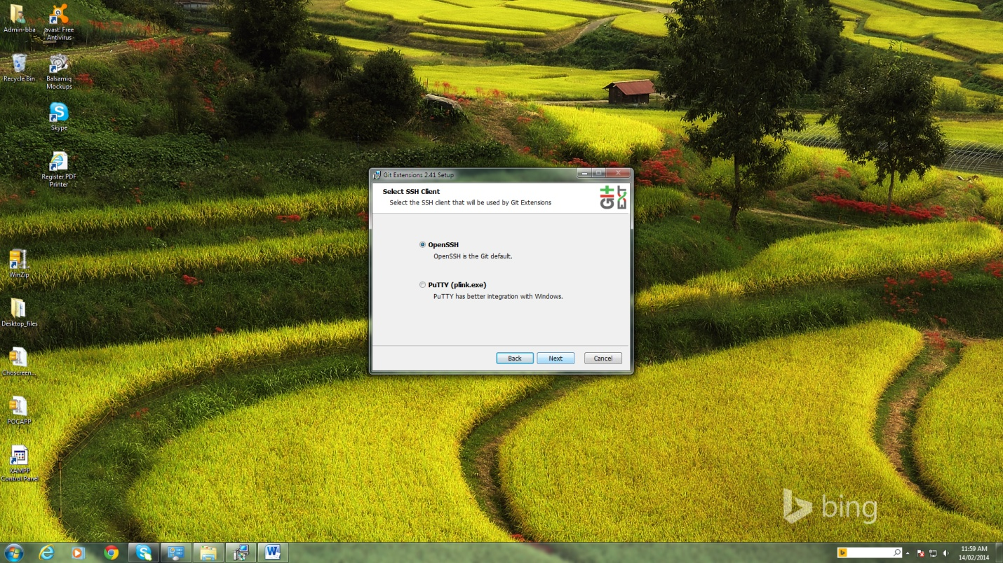

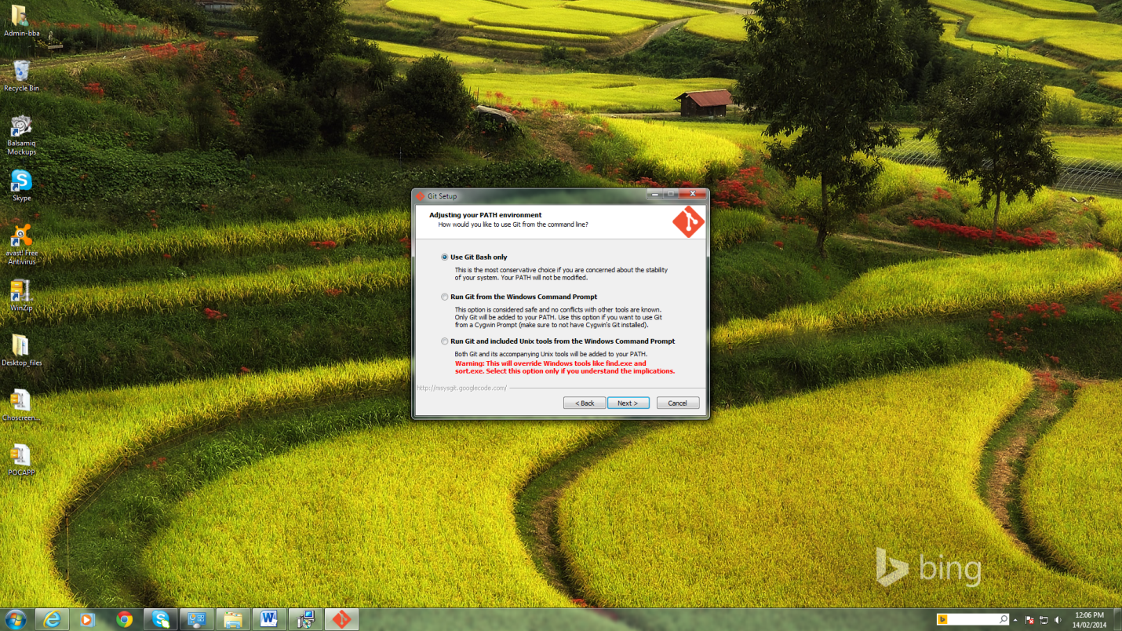

After this screen KDiff3 and GitBash will install.OnceGithub installation is completed below screen will open. (Very first time ).

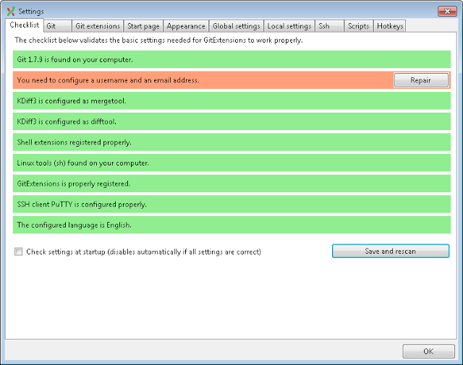

If we press Repair button below screen will open.

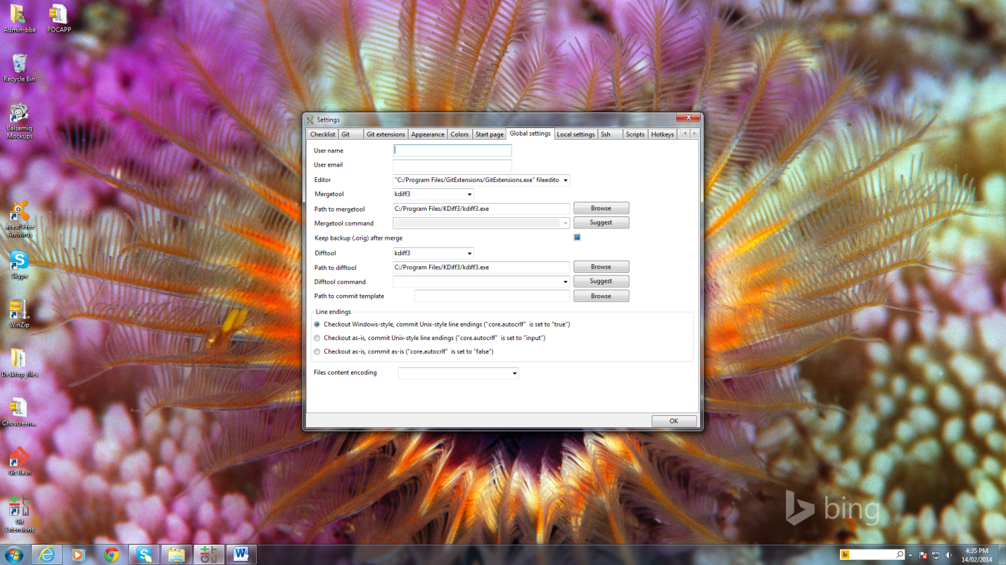

In this screen we have to fill all information i.e.username and email id (GitHub)

Note:Before giving username and user email we should create account for us (<https://github.com/>)

How to create sshkey:

Step 1: open GitBash screen

Step 2:Type the command ssh-keygen -t rsa –C “[boopathytcu@gmail.com](mailto:boopathytcu@gmail.com) “ .Now key has been generated in default location.

Step 3.Add your SSH Key to GitHub (Copy id_rsa file).

* Go to Account Settings
* Click “[**SSH Keys"**](https://github.com/settings/ssh)**in the** left sidebar
* Click Add SSH Key
* Click "Add key"
* Confirm the action by entering your GitHub password

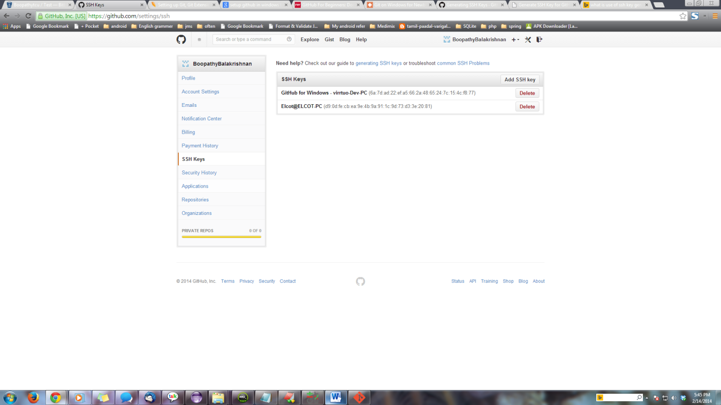

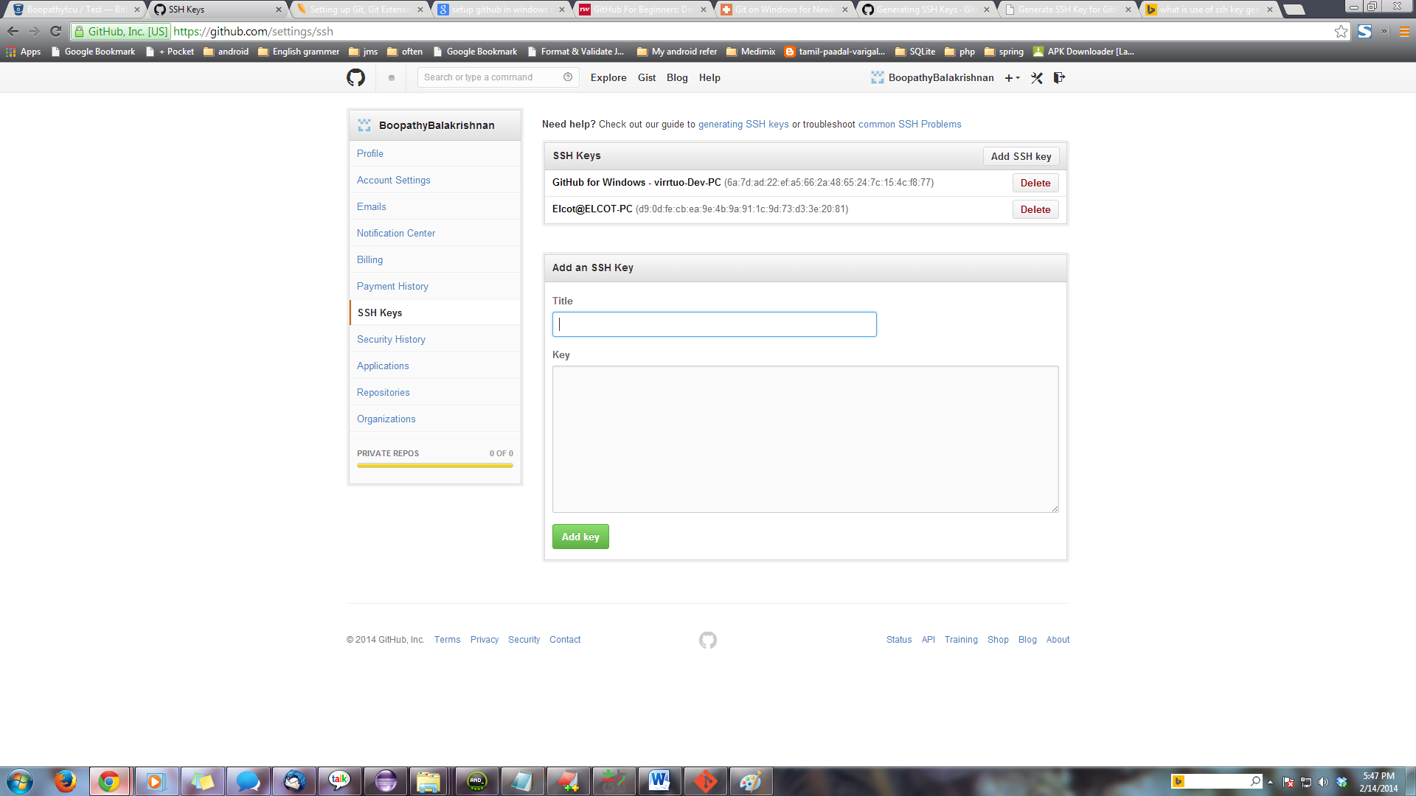

How to clone github:

Copy giturl from repository [**git@github.com:BoopathyBalakrishnan/NjN.git**](mailto:git@github.com:BoopathyBalakrishnan/NjN.git)

**Open GitExt click clone Repository**

